SERENITY: Smart Emotion Recognition & Neural Intervention Technology
Hardware:
- Nvidia Jetson Nano
Datasets:

Emotion Recognition from Facial Images (CNN)
- Dataset:FER-2013
- Emotion classes: Angry, Disgust, Fear, Happy, Sad, Surprise, Neutral
- Grayscale 48x48 images – small enough for embedded deployment

Speech Emotion Recognition
- Dataset:RAVDESS Emotional speech audio
Audio clips in WAV format with emotion labels
Good for training a speech emotion classifier
Alternative: CREMA-D, TESS (for better age/gender balance)
- For fine tuning System LLM

DAIC-WOZ

Why: Clinical interviews with depression severity labels

What It Covers: Transcripts of interviews with PHQ scores

Use: Align user responses to emotion or diagnostic traits

Access: Requires approval – Apply here

DAIC-WOZ Database Download - DAIC-WOZ

2. Counseling & Therapy Dialogues

[EmpatheticDialogues (Facebook AI)]
- Task: Empathetic response generation
- Use: Fine-tune TinyBERT to generate emotionally aware responses
EmpatheticDialogues Dataset | Papers With Code

3. CounselChat Dataset
- Task: Real questions and therapist answers (categorized by topic like depression, trauma, grief)
- Use: Build realistic question-answer pairs for fine-tuning
nbertagnolli/counsel-chat · Datasets at Hugging Face
nbertagnolli/counsel-chat: This repository holds the code for working with data from counselchat.com

PHQ-9 Questions
Over the last 2 weeks, how often have you been bothered by any of the following problems?
- Little interest or pleasure in doing things
- Feeling down, depressed, or hopeless
- Trouble falling or staying asleep, or sleeping too much
- Feeling tired or having little energy
- Poor appetite or overeating
- Feeling bad about yourself — or that you are a failure or have let yourself or your family down
- Trouble concentrating on things, such as reading the newspaper or watching television
- Moving or speaking so slowly that other people could have noticed.
Or the opposite — being so fidgety or restless that you have been moving around a lot more than usual
- Thoughts that you would be better off dead or of hurting yourself in some way

Scoring System
Each item is rated:
- 0 – Not at all
- 1 – Several days
- 2 – More than half the days
- 3 – Nearly every day
Total Score | Depression Severity
0–4 | Minimal or none
5–9 | Mild
10–14 | Moderate
15–19 | Moderately severe
20–27 | Severe

GAD-7 Questions
“Over the last 2 weeks, how often have you been bothered by the following problems?”
- Feeling nervous, anxious, or on edge
- Not being able to stop or control worrying
- Worrying too much about different things
- Trouble relaxing
- Being so restless that it is hard to sit still
- Becoming easily annoyed or irritable
- Feeling afraid as if something awful might happen

Scoring System
Each item is scored from:
- 0 = Not at all
- 1 = Several days
- 2 = More than half the days
- 3 = Nearly every day
Total Score | Anxiety Severity
0–4 | Minimal anxiety
5–9 | Mild anxiety
10–14 | Moderate anxiety
15–21 | Severe anxiety

PCL-5 Full List of Questions
“In the past month, how much were you bothered by…”

🔹 Intrusion Symptoms
- Repeated, disturbing, and unwanted memories of the stressful experience?
- Repeated, disturbing dreams of the stressful experience?
- Suddenly feeling or acting as if the stressful experience were happening again (as if you were reliving it)?
- Feeling very upset when something reminded you of the stressful experience?
- Having strong physical reactions when something reminded you of the stressful experience?

🔹 Avoidance Symptoms
- Avoiding memories, thoughts, or feelings related to the stressful experience?
- Avoiding external reminders (e.g., people, places, conversations, activities) of the stressful experience?

🔹 Negative Alterations in Cognition and Mood
- Trouble remembering important parts of the stressful experience?
- Having strong negative beliefs about yourself, other people, or the world (e.g., "I am bad," "No one can be trusted")?
- Blaming yourself or someone else for the stressful experience or what happened after it?
- Having strong negative feelings such as fear, horror, anger, guilt, or shame?
- Loss of interest in activities you used to enjoy?
- Feeling distant or cut off from other people?
- Trouble experiencing positive feelings (e.g., love, happiness, satisfaction)?

🔹 Arousal and Reactivity Symptoms
- Feeling irritable or having angry outbursts?
- Taking too many risks or doing things that could cause harm?
- Being “super alert” or watchful or on guard?
- Feeling jumpy or easily startled?
- Having difficulty concentrating?
- Trouble falling or staying asleep?

Scoring and Interpretation
- Total score range: 0–80
- Clinical cutoff: ≥31–33 suggests probable PTSD
- Can also use symptom cluster scores for DSM-5 diagnosis

Models:
- System LLM
  - TinyBERT
  - Pretrained-Language-Model/TinyBERT at master · huawei-noah/Pretrained-Language-Model

- Speech-to-Text (STT)
  - Converting the user’s spoken audio input into text so it can be analyzed for emotional content.
  - Model: Whisper Tiny

whisper.cpp (Highly Recommended)

- Text-to-Speech (TTS):
  - FastSpeech2
  - Since training from scratch is huge, here’s what you can do now:
  - Step 1: Pick a base model
  - FastSpeech2 + HiFi-GAN (good balance of speed/quality).
  - Step 2: Get datasets
  - For voices: VCTK (109 speakers, English).
  - For emotions: ESD (15k clips, 5 emotions, multi-speaker).
  - Step 3: Finetune
  - Train the TTS model with both speaker and emotion labels.
  - Example input to model:
  - Text → Phonemes + Speaker ID + Emotion ID → Mel-Spectrogram → Vocoder → Audio
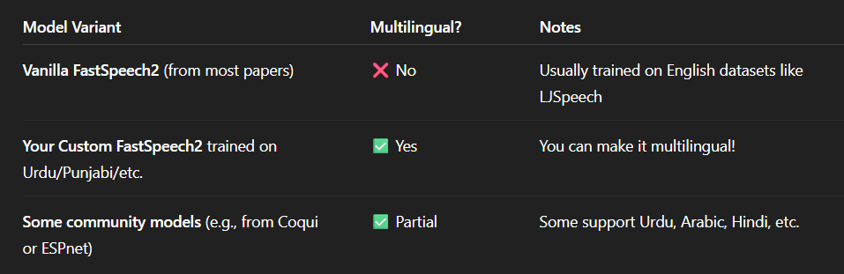
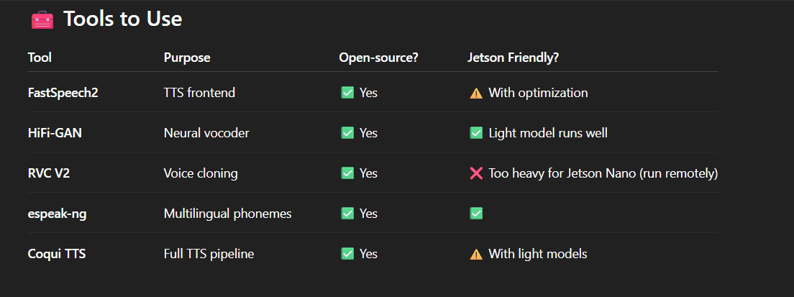

4. Voice Personification
  - RVC V2 (but it is very resource hungry)
  - Fine tuning of FastSpeech2 to generate empathetic voice

5. Speech Emotion Recognition
  - Model: Speech emotion recognition 97.25% accuracy
  - CNN/LSTM

6. Image Emotion Recognition
  - Model: facial_emotion_recogination 91% accuracy train set
  - CNN

System LLM (fine tuned Tiny BERT)
- fine tuned to automatically judge the user's mental states such as Depression, Anxiety and Trauma
- PHQ-9, GAD-7, PCL-5
- 5 types of therapies

1. CBT (Cognitive Behavioral Therapy) – Highly LLM-Compatible
Help users identify, challenge, and reframe negative thoughts.

LLM Implementation Ideas:
- Detect cognitive distortions (e.g., catastrophizing, black-and-white thinking)
- Guide users through Socratic questioning:
"What evidence supports this thought?"
"Can you think of an alternative explanation?"
- Daily thought journal prompts
- Mood-tracking conversations
Ideal for depression and anxiety
Can be personalized and tracked
Needs logic structure + emotional awareness

2. Supportive Therapy / Active Listening
Focuses on empathetic conversation and validation of emotions.

LLM Implementation Ideas:
- Reflective listening:
"It sounds like you’re feeling overwhelmed after the event yesterday…"
- Reassurance without problem-solving
- Normalizing emotions:
"It's okay to feel anxious before a big change."
Lightweight, runs well even with smaller models
Enhances user trust
Must maintain tone neutrality and avoid giving harmful advice

3. Solution-Focused Brief Therapy (SFBT)
Short, goal-oriented, focused on user strengths.

LLM Implementation Ideas:
- Ask “miracle questions”:
"If you woke up tomorrow and your anxiety was gone, what would your day look like?"
- Help set small, actionable goals
- Track progress over days
Great for brief sessions
Works with short-term memory
Limited depth for complex trauma

4. Mindfulness & Grounding Techniques
Reduce stress and trauma symptoms through calming exercises.

LLM Implementation Ideas:
- Guided breathing or body scans
- Grounding scripts:
"Let’s focus on 5 things you can see, 4 you can touch…"
- Suggest daily affirmations or check-ins
Very Jetson-friendly
Ideal for trauma-sensitive care
Needs speech tone support for optimal effect (TTS emotion synthesis)

5. Narrative Therapy Elements

Help users explore how they describe their problems, reframe identity.

LLM Implementation Ideas:
- Prompts like:
"Can you tell the story of when you first felt this way?"
"What name would you give this problem?"
- Help separate the person from the problem
Good for building long-term sessions
Requires some memory or contextual continuity

